Seafood Processor News™

Vol. 1, No. 1 July, 2005

Reported independently by Seafood Processor News, div. Indumark®, New York, NY

Special Replacement Grinders
Improve Discharge Compliance for Major Seafood Processor

Also Ease Operation, Lower Power Requirement,
Reduce Maintenance, and Enhance Safety

Cordova, AK --- Production and engineering managers for both at-sea and land-based seafood processing plants operated by Norquest Seafoods Inc. in Alaska report significantly improved discharge compliance through installation of special replacement grinders for remains processing. They also note easier operation, lowered power requirement, reduced maintenance, and enhanced safety for remains handling.

The Muffin Monster® grinders were designed and manufactured by JWC Environmental of Costa Mesa, CA, and provided locally by their application specialist APSCO Inc. of Kirkland, WA.

“We are required to grind remains such as fish heads to particles having diameters of ½” or less before we can discharge into Alaskan waters,” noted Lee Murrell II, now roe manager at the Cordova plant. “When we replaced our previous grinder with this one in 2000 on our Aleutian Falcon floating processor, we were then able to meet the requirement consistently for all the various seafood remains applications we put through it, and also ended the problem of the grinders plugging up, overflowing, and having to be reversed to clear them.”

“Then, when we tried them at the startup of the land-based Adak plant in 2001,” he continued, “we also had excellent results there, and have now installed them throughout the company.”

Murrell said the Aleutian Falcon was processing 10-11 million lbs. of round product annually, including salmon, herring and snow crab, operating 24/7 for five months, with remains volume to be grinded running at about 23%, or 2.5 million lbs.

(more)

Seafood Processor News, July, 2005, text p. 2 of 4

At the Adak plant, established to gain a foothold for the company in the processing of Pacific cod (“pcod”), success was documented initially through 45 consecutive days of 24/7 operation, with volume averaging about 150,000 lbs/day of pcod, halibut, rock fish, and king crab round product, and remains volume running at about 55%.

“That included the grinder handling severe duty #6 or #7 stainless steel hooks, with 12/0 or 13/0 openings, that we couldn’t remove from 100% of the heads,” he noted. “It also had to handle rocks ingested by the pcod. We also worked to remove those, by taking out the stomachs, in an effort to minimize replacement we had to perform for the grinding teeth and gears, which we understood weren’t designed for rocks or heavy duty hooks.”

At the company’s Cordova plant, manager Bill Gilbert has also noted improved discharge compliance through installation of a replacement grinder, while plant engineer Brian Parsons has designed an installation for a second grinder.

“We were getting improvement in discharge compliance to the level of about 95% with the replacement grinder, and are installing another one for secondary treatment so we can do even better,” Gilbert said.

At the Chignik plant, production manager John Lombardo has observed significant operational and safety improvements as well as improved discharge compliance since the installation of a replacement grinder in 1999. A second unit was added in 2004.

“The previous unit operated similar to a hand-held meat grinder in a butcher shop,” he recalled, “with an auger pushing remains into a blade on the back side of a plate with ½” diameter holes. The remains came out the other side with only a ½” diameter to meet discharge compliance, but it was questionable that they would be only ½” long.”

“Meanwhile, it was too limited on the remains receiving side by the width of the deepest groove of its auger,” he continued. “It could handle 5” circumference heads from regular salmon, but 8” circumference or larger heads from king salmon or halibut would pop up and down unless we applied downward force by other means.”

“Another way we handled the input problem was to chop larger salmon heads in half with a butcher knife, and for the halibut heads that ran as large as 12” diameter, we installed a bandsaw on the production floor just for splitting them.”

“With the replacement unit, all that is history. We can put a 200-lb. fletched halibut in tail first, and it sucks the carcass right in. We can put in a whole 30-lb. halibut head, and it is reduced to puree in about 15 seconds.”

(more)

Seafood Processing News, July, 2005, text p. 3 of 4

“The replacement grinders are pretty much maintenance-free during a season. We change the blades every other season, unless we’re running pcod with rocks in their stomachs. There, we’re hoping to find a way to have the blades last more than one season.”

Dale McBain of APSCO Inc., JWC Environmental’s local application representative,
recalled that power consumption had also been a major concern with the previous grinder.

“In addition to having a larger footprint and lower feed rate, the previous manufacturer’s units ran at a minimum of 30 HP,” he said. “The replacement runs at only 5 HP at the feed rates they need, and has been easy to integrate into their production operations.”

“They’ve been successfully installed in different orientations, including at a 45 degree angle to the floor, so that gravity holds the remains against the cutter, and also horizontally, so that the cutter opening points straight up, receiving feed from a hopper above the unit.”

The dual-shafted Muffin Monster made by JWC Environmental for this application offers grinding of a wider variety of solids than its single-shafted machines, while its low-speed operation results in higher torque and less interrupts. Its special cutter teeth were developed specifically for fish remains service.

Various cutter combinations are available in all the company’s grinders to allow for exit particle size as fine as ¼ in. for 95% of ground material. Cutter elements are engineered in many variations to accommodate specific needs, and units are provided for both in-line and channel configurations. The company also offers a bigger, heavier-duty grinder called the Macho Monster for particularly tough solids.

The units are commonly deployed in chemical, petrochemical, pulp & paper, food, and other industrial processing applications, as well as for a wide variety of recycling, remediation, and wastewater uses.

They have effectively reduced particle size for wood, plastics, rocks, nuts, bolts, wire, sludge, and other foreign material that could otherwise foul or damage waste stream and process equipment, and have also typically provided for reduced handling costs associated with solids removal.

The company adds that the units adapt to most applications with little or no modification to piping, channel, or power, and offer high-pressure (90 psi) capability, with no seal flush required and no packing gland to adjust.

(more)

Seafood Processor News, July, 2005, text p. 4 of 4

Sales and service offices are located throughout the U.S. and in Europe. For further information, contact JWC Environmental, 290 Paularino Ave., Costa Mesa, CA 92626, Tel. 800/331-2277, Fax 949/833-8858, www.jwce.com, jwce@jwce.com.

###

(five photos follow)

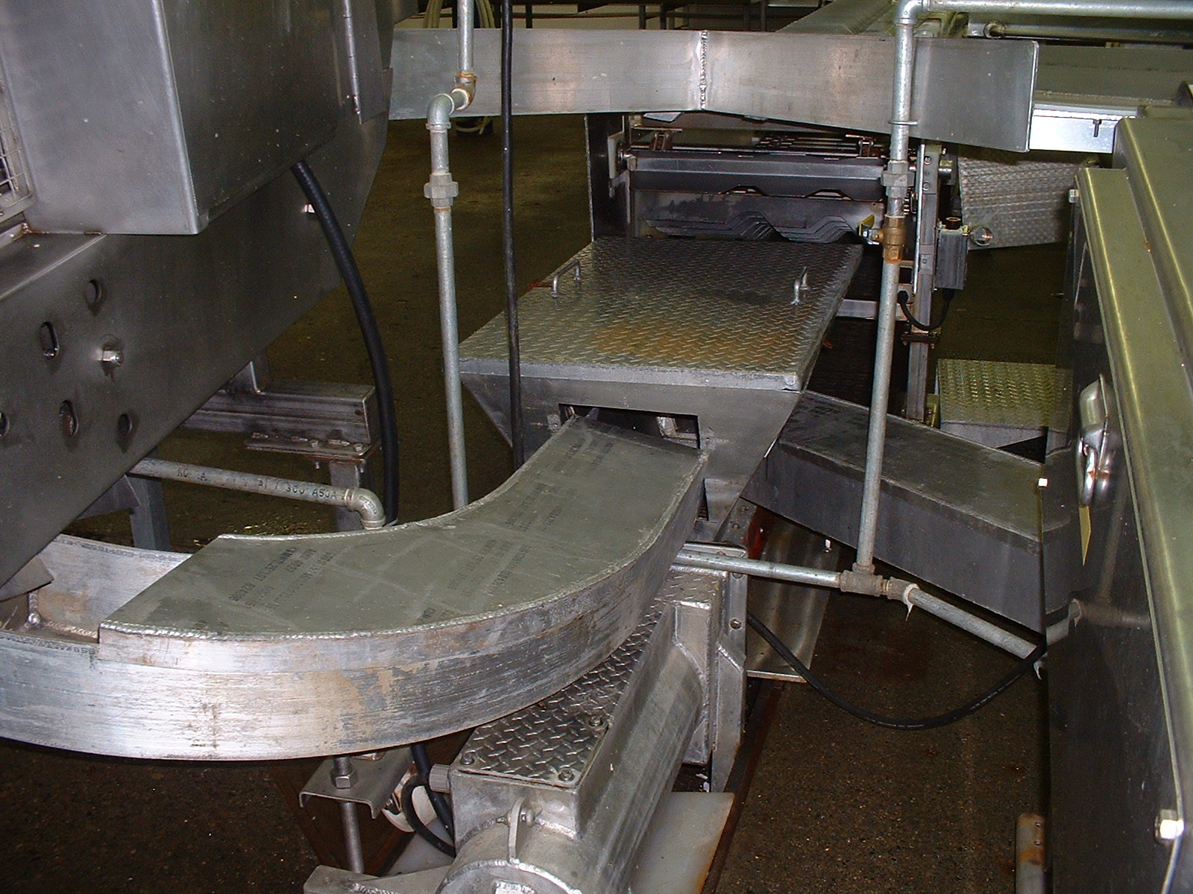

Photo #1

Major seafood processor’s production and engineering managers for both at-sea and land-based plants report significantly improved discharge compliance and other benefits through installation of special replacement grinders for remains processing. Replacement grinder units have been deployed to handle one or more product lines, with various types of remains conveyed separately to grinders as desired.

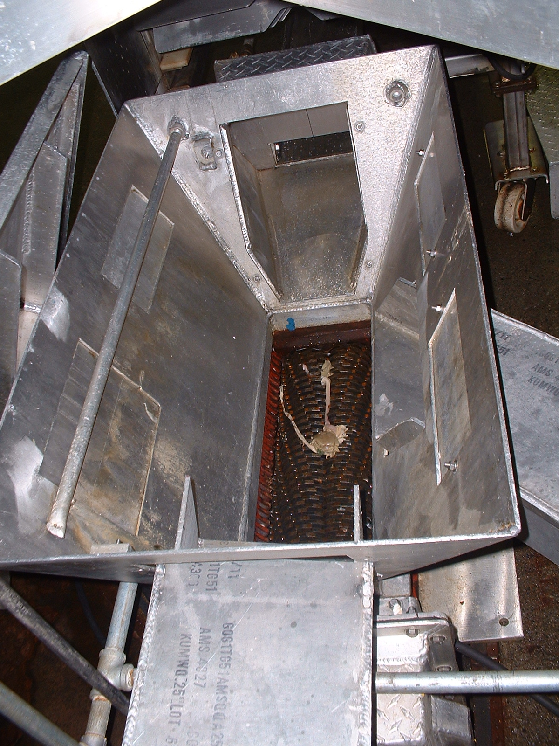

Photo #2

The dual-shafted Muffin Monster made by JWC Environmental for seafood processing applications features special cutter teeth developed specifically for fish remains service.

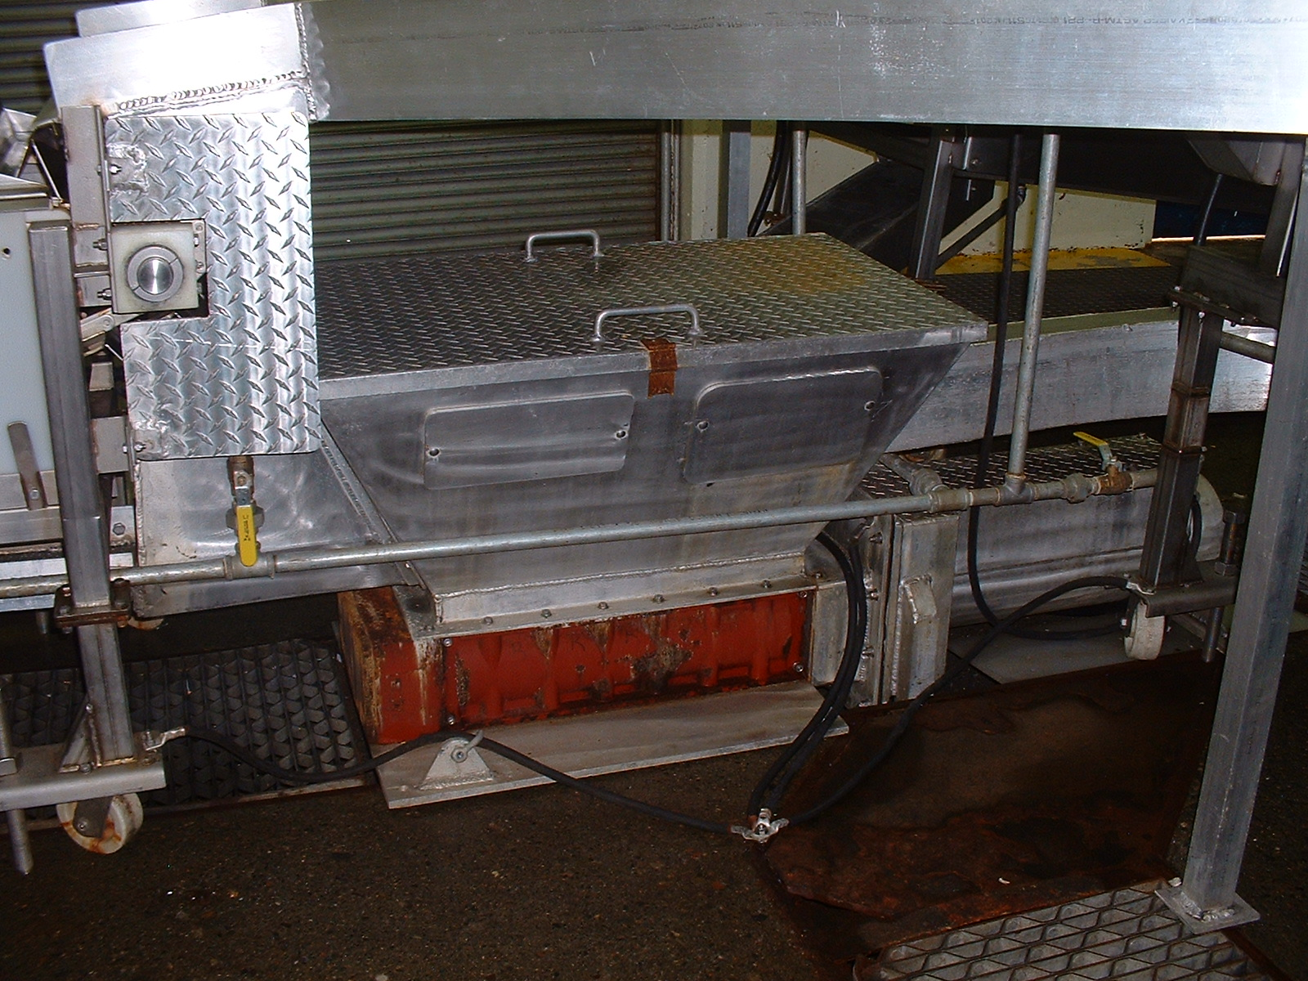

Photo #3

Replacement grinders have been successfully installed in different orientations, including horizontally, so that the cutter opening points straight up, receiving feed from a hopper above the unit.

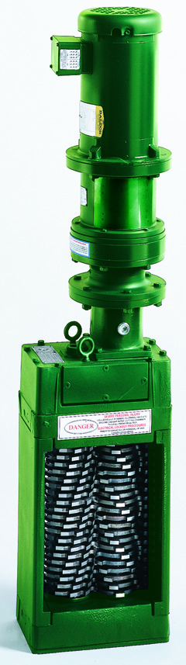

Photo #4a

Channel-type Muffin Monsters were deployed with revised, customized pipeline setups.
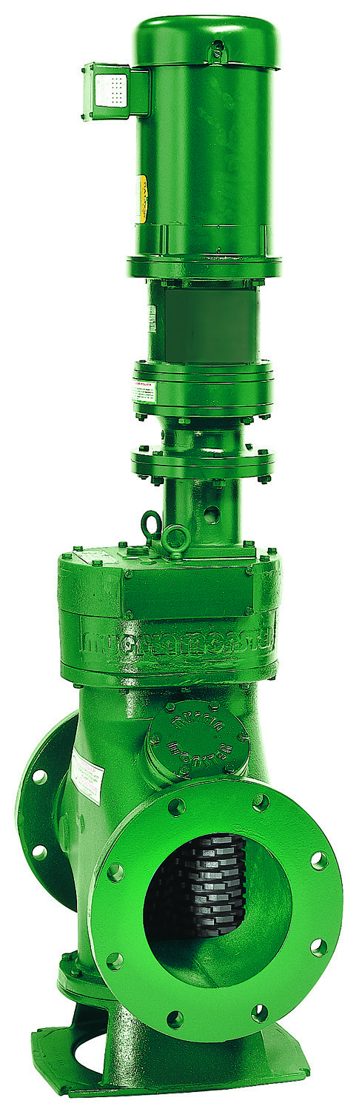 Photo #4b
In-line type Muffin Monsters were deployed to fit into existing pipeline setups.

